**QUESTIONNAIRE FOR SCHOOL STUDENTS:**

**DATA MANIPULATION:**

1. The equation x^2 +3x+1= 0is know as

a**) Algebraic equation**

b) Polynomial equation

c) Cubic equation

d) Transcendental equation

2. Which of these measures used to analyze the central tendency of data?

a) Mean and normal distribution

**b) Mean, median and mode**

c) Range and mean

d) Median, range and normal distribution

3. Runs scored by 10 batsmen in a one - day cricket match is given. Find the average runs scored.

23, 54,08,94,60,18,29,44,05,86

**a) 42.1**

b) 55.32

c) 43.6

d) 39.9

4. Accuracy refers to how closely a calculated value agrees with

a) Each other

**b) True value**

c) No other value

d) Same value

5. Precision refers to how closely a calculated value agrees with ______.

**a) Each other**

b) Same value

c) No other value

d) True value

**QUANTITATIVE:**

1. What is the value of (-5) * (-7)?

**a) 35**

b) 42

c) -35

d) -45

2. Five years ago the ratio between ages of Meena and Sita was 3:4. After five years from now the ratio between their ages will be 5:6. Find the present age of Meena?

a) 22 years

b) 25 years

c) 15 years

**d) 20 years**

3. What is 7/20 as decimal?

**a) 0.35**

b)0.34

c)0.21

d)0.30

4. Find the factors of 3m^2+9m+6

**a) -1, -2**

b)-2, -3

c) -1, -3

d) -2, 3

5. Three numbers are in ratio of 2:3:4 and their L.C.M is 240. What is their H.C.F?

a) 40

**b) 20**

c) 10

d) 30

**VERBAL:**

1. She has been studying ______ two hours.

**a. For**

b. Since

c. From

d. Till

2. Identify the grammatically CORRECT sentence from the given choices

a) The woman to who I sold my house was a doctor.

b) The woman that I sell my house was a doctor

**c) The woman to whom I sold my house was a doctor**.

d) The woman who the house I sold to was a doctor.

3. He has not recovered fully ----------the shock of his failure.

a) Against

**b) From**

c) Of

d) Off

4. Choose the exact opposite of **Rebuked**

a) awarded

b) invited

c) received

**d) praised**

5. Animate: Find the synonym.

a) Kill

b) Dead

**c) Energize**

d) Calm

**SITUATIONAL (ENTERPRISING):**

1. You are a department manager and you have recently thought of a new procedure that you believe would improve the work process. Some of the employees in your department agree with the change and some do not. One of your employees openly criticizes the idea to your director.

What would you do and why? Choose one option.

a) You decide not to respond to the critics in order to avoid unnecessary conflict.

b) You reprimand the employee for going over your head to the director and work to promote your idea with even more enthusiasm.

**c) You meet the employee for talk and explain that bypassing your authority is unacceptable**.

d) Employees trust in their manager is important so you decide to implement only some of the changes to keep my employees satisfied.

2. If in ty examination hall, you find that the question paper is tough to be answered satisfactorily by you, the best thing to do for you is to:

a) Tell the examiner provoke that the questions are out of course .

b) Provoke the candidates to walk out of the examination hall.

c) Try to know something from neighbour

**d) Try to solve the question as much as you know with a cool head**

3. While you find a suitcase beneath your seat. You would:

**a) Report the matter to the police**

b) Open up the suitcase to look through it’s contents.

c) Try to find out the address of the owner from the papers etc, in suitcase.

d) Finding no one to claim it, take it into your own possession.

4. You are interviewed for a new job. Which of the following questions is most important to you?

a) Opportunities for promotions.

b) Remuneration you will be paid.

c) Scope to develop your ideas and use them to improve the working of the organization.

**d) All the above are equally important.**

5. You are a team leader and you are supposed to hold a convention on HR issue. But your team members are unable to get adequate sponsorship.

a) You put in your money and hold the event as scheduled.

**b) You try and motivate them that they can do it.**

c) You postpone the event and give them some more time.

d) You tell them things can work out like this and cancel the event.

**SITUATIONAL (SOCIAL):**

1. While travelling in your car, certain person’s stop you on the way asking you to take an injured child to the hospital. You would:

a) Ask them to leave your way and then drive away

b) Ask them to first call the police

**c) Immediately take the child to hospital**

d) Get out of the ask some other person to help to take the child to hospital

2. Main objective of educational guide is to bring what change in the pupil.

a) Psychological development of the child

b) Responsibility of self direction

**c) Both the above**

d) None of the above

3. Which of following should be considered the most important quality of a teacher at primary level?

a) Eagerness to teach

**b) Patience and perseverance**

c) Competence in method of teaching and knowledge of subjects

d) Competence to teach in highly standardized language

4. You are a social worker and you visit an orphanage, then one child who is not ready to let you go away

a) You decide to visit him every Sunday

b) You leave with no concern

c) You ignore the child because you have other kids to attend

**d) You talk to the authorities and arrange for parents who can adopt him.**

5. Which of the following is not a sign of an intelligent young child?

**a) One who has ability to cram along long essays very quickly**

b) One who has the ability to communicate fluently and appropriately

c) One who carries on thinking in abstract manner

d) One who can adjust oneself in a new environment

**SPATIAL AND TEMPORAL REASONING:**

1. How many triangles are there in the given figure?

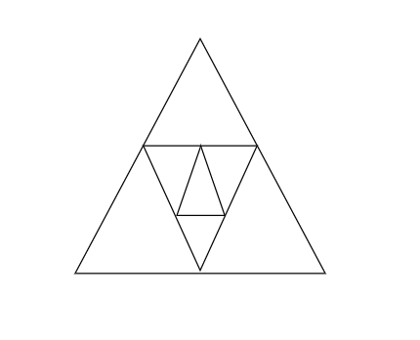

**a) 9**

b) 13

c) 16

d) 11

2. Start at one of the corner letters and move clockwise around the square finishing in the centre to create a nine-letter word.

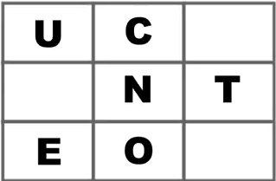

**a) EDUCATION**

b) EDUCATED

c) CEMENTRY

d) ICESTOLEN

3. Which figure is identical to the first?

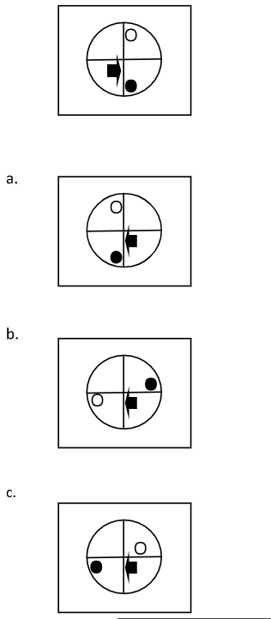

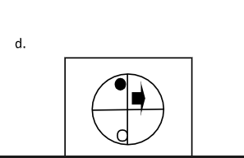

**ANS - a**

4. Which of the examples matches the shape when joined together by corresponding letters?

b

a

a

b



c)

d) None of the above

ans - b

5. Which of the given shapes is the rotation of the main image?

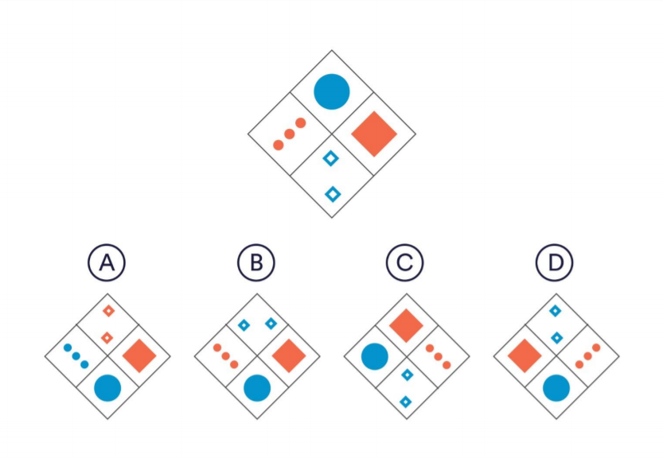

1. A
2. B
3. C
4. **D**